
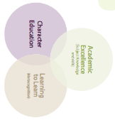
Galmpton C of E Primary Long Term Planner whole school 2024/25

Autumn 1 |  |  | Autumn 2 |  |  |  | Spring 1 |  |  | Spring 2 |  |  | Summer 1 |  | Summer 2
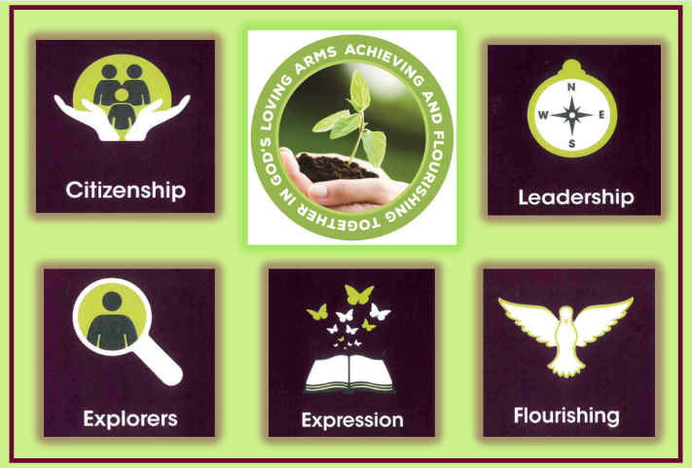  Citizenship |  |  | Exploration   |  |  |  | 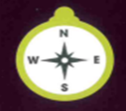  Leadership |  |  |   Expression |  |  | 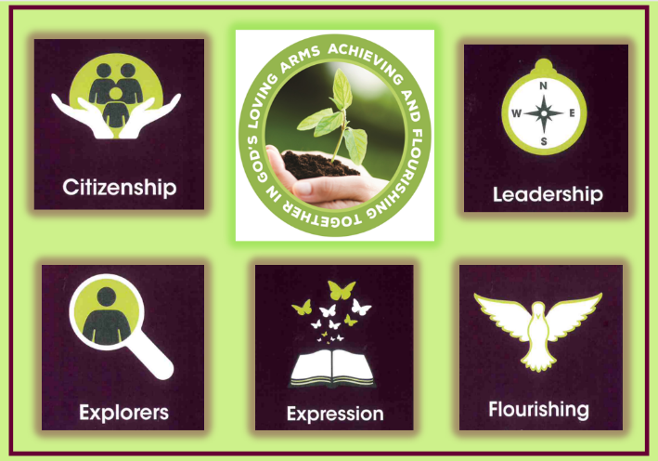  Flourishing |  | Citizenship  
Subject Learning Enquiries
Metacognitive strand  Independence |  |  | Metacognitive strand  Creativity |  |  |  | Metacognitive strand  Collaboration |  |  | Metacognitive strand  Independence |  |  | Metacognitive strand  Creativity |  | Metacognitive strand  Collaboration
RSHE  2 weeks | RWE  2 weeks | Geography  3 weeks | Science  3 weeks | Narrative  Writing  2 weeks | Art  2 weeks | History  2 weeks 3 days |  | Science  3 weeks | Writing  2 weeks |  | DT  2 weeks | Art  2 week | Geography  2 weeks | Science  2 weeks  3 days | History  3 weeks | DT  Cooking  1 week | RSE 2 days | Music/  Drama  2 weeks
What are refugees and how can we support them? | What would the Ten Commandments be if written today? | Which region of Catalonia would I prefer to visit on holiday? | Why are forces fundamental to our lives? | How can the story of The Lion, The Witch and The Wardrobe inspire my own writing? | How can I develop as an artist by studying the work of Van Gogh? | Did King Alfred deserve the title ‘The Great’? |  | Which is more important to a healthy life; the skeleton or the digestive system? | Story-writing narrative |  | Can I design and test a…? | How can I create a sculpture worthy of a community art sale? | Which earthquake was the most Catastrophic: Haiti 2021or Turkey 2023? | How does light travel and how are sounds made? | Why did Henry VIII have so many wives and which one was the greatest? | Whole school cooking project | How do our bodies change? | Performance
I know what empathy means  I know that care is a two-way process | I can explain my own beliefs and how these impact the way I choose to live. | A European region  I know the relationship between physical geography and human | I know how things move  I know that forces need contact between two objects  I know that magnets attract and repel | I know how to use adverbial phrases  I can use expanded noun phrases  I can punctuate speech. | I know how to mix paint I know tertiary colours I can use mixed media | I know why raids happened I know why people settled I know about a significant person |  | I know the functions of the teeth and the digestive system I know how the skeleton supports the body | I can use adverbial phrases  I use expanded noun phrases |  | I can explain my design features I can explain my choices Make a prototype | I know how to coil shape and mold.  I know how to use different materials for different effects | Contrasting non-European region  I know areas at risk and why.  I know regions can be at risk from natural disasters. | I know how light travels and how shadows are formed  I know how sound is made and how it travels | I know significant events of the Tudor times  I know how experiences were different for different people |  | I understand physical changes during puberty.
Writing Genres
Poetry | Justification of my own golden rules | Persuasive text | Investigation – report | Narrative | Critical review and notetaking | Balanced argument |  | Non-chronological report | Narrative |  | Reflection | Biography | Non chronological report | Science report | Letter | Reflection
Teaching of Other Subjects
Metacognition (learning to learn day takes places on the first day of every half term
Religion and Worldviews – a core subject also taught weekly Music- weekly lessons using the Charanga programme MFL-weekly lessons using the PLN Spanish Programme
PE/Games including swimming in KS2 taught weekly

