Art terminology
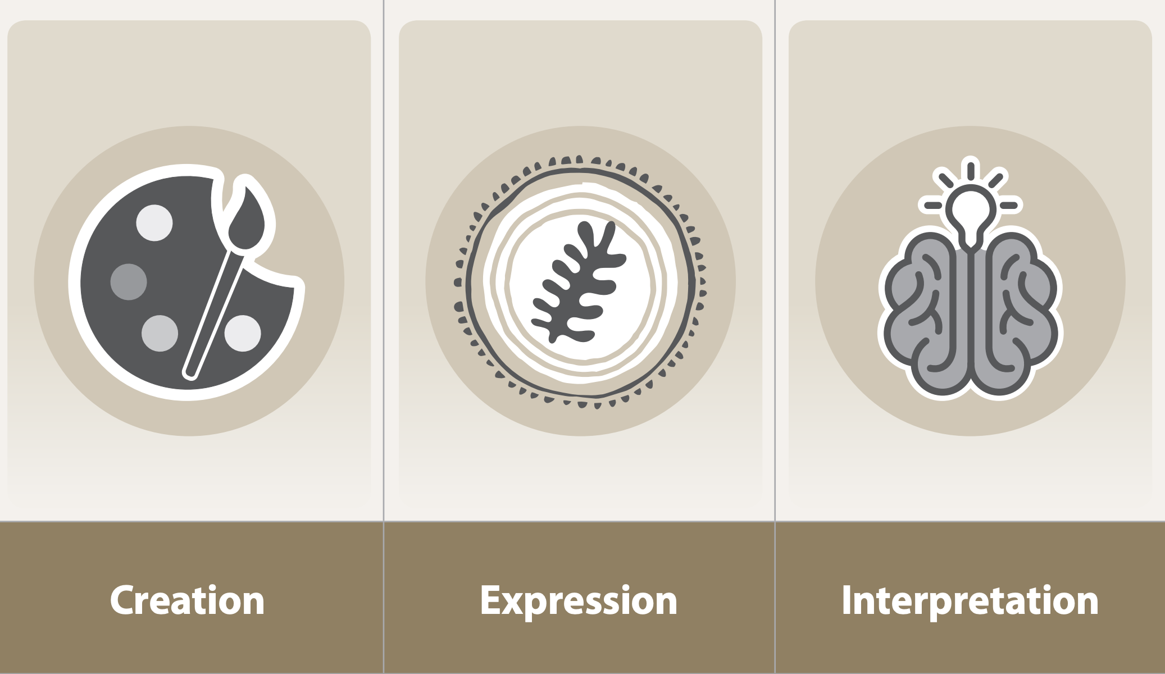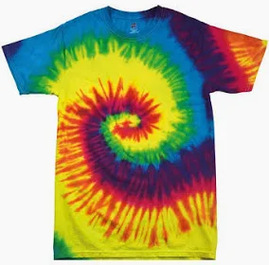
printing | The act of producing letters, pictures, patterns, etc. on something by pressing a surface covered with ink.
relief | Relief printing is when you carve into a printing block that you then use to press onto paper and make a print.
press | The printing press is a machine that uses ink to transfer words and images to paper.
rubbing | A rubbing (frottage) is where you copy the texture of a surface by placing a piece of paper over the item and then rubbing the paper with colour,
pressure | Pressure printing is an image making method where a backing sheet or flexible plate is positioned behind a press sheet and then run over a certain inked, type high surface.
roller | Roller printing uses engraved rollers to print on fabric surfaces.
End of Enquiry Learning:
- I know ways of printing including relief and press.
- I know that pressure of printing affects tone.
- I know how to produce a rubbing.
- I know how to make a relief print.
- I know about an artist who used the media of print.
- I can create prints using different colours and shades.
- I can create prints using different techniques.
- I can explain how different ways of printing work.
Art Learning Organiser Year 3
Can I print my own T-shirt design that I can wear with pride?

