
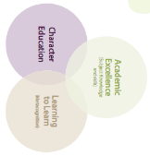
Galmpton C of E Primary Long Term Planner whole school 2024/25

Autumn 1 |  |  | Autumn 2 |  |  | Spring 1 |  | Spring 2 |  |  | Summer 1 |  | Summer 2
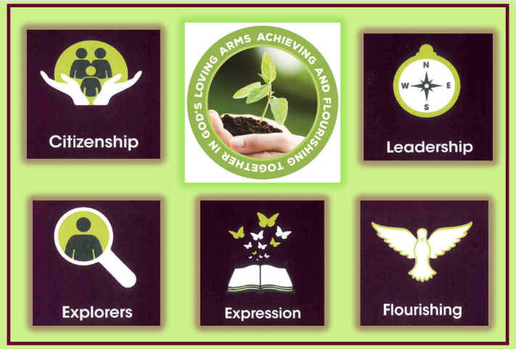  Citizenship |  |  | Exploration   |  |  | 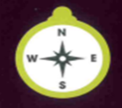  Leadership |  | 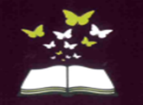  Expression |  |  | 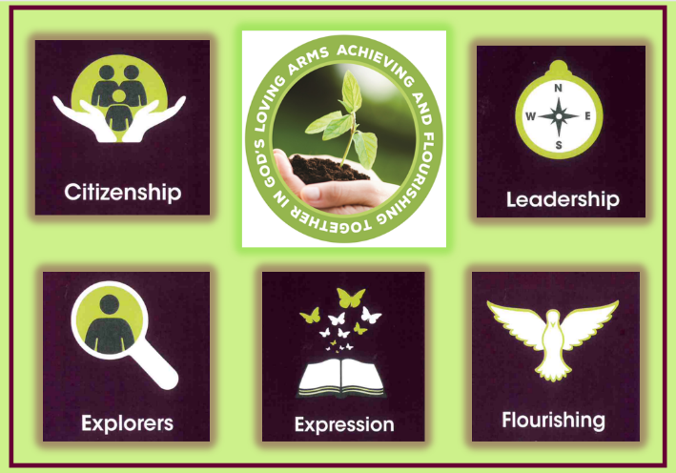  Flourishing |  | Citizenship  
Subject Learning Enquiries
Metacognitive strand  Independence |  |  | Metacognitive strand  Creativity |  |  | Metacognitive strand  Collaboration |  | Metacognitive strand  Independence |  |  | Metacognitive strand  Creativity |  | Metacognitive strand  Collaboration
RSHE  2 weeks | RWE  2  Weeks | Geography  3 weeks | Science  3 weeks | Narrative  Writing  2 weeks | Art  2 weeks | History  2 weeks 3 days | Science  3 weeks | Writing  2 weeks | DT  2 weeks | Art  2 weeks | Geography  2 weeks | Science  2 weeks  3 days | History  3 weeks | DT  Cooking  1 week | RSE 2 days | Music/ Drama  2 weeks
How can we show respect to everyone?  I can show care for others.  I know secuirty and love are important.  I know what makes a good friend and how to be a good friend.  I know the importance of helping. | Whole school RWE experi-ence | How great is Galmpton?  I know how to use a simple local map to identify different features.  I know what are man-made and natural features.  I know the four compass points.  I know my locailty and its features. | How can science help us build a bridge?  I know the names of common materials and can compare and group materials together.  I can suggest the suitability of materials.  and simple properties of materials.  I know the impact of simple forces on materials.  I can perform a simple test. | How can I retell the best Christmas Story?  I can use conjunctions to add more detail to my sentences.  I can start every sentence with a capital letter and finish with a full stop. | How can I create a christmas inspired piece of art with shapes?  I know to join a range of materials.  I know how to shape different materials.  I know the difference between 2D and 3D shapes.  I know a sculptor and how they work. | How have things changed in my lifetime?  I know how to sequence an event from the time I was born to the present time.  I know changes that have happened in my lifetime using past and present.  I know how to put pictures in order to tell a story of my life.  I can talk about the details in pictures. | What do plants need to thrive?  I know the names of common plants. I know how plants grow and if it is healthy.  I know the difference between deciduous and evergreen  I know the impact that water, temperature and food have on plants. | Can we create a tigers tale?  I can use conjunctions to add more detail to my sentences.  I can use adjectives to give a character or setting more description. | How can I build a car to go over a bridge?  I can say what I am trying to make and who will use my product.  I know how materials have different appearance I know how to identify wheels, levers, sliders and axils.  I know how to measure, mark and cut to make a product. | How can I create a Pablo Picasso inspired art piece?  I know what lines can be created using materials.  I can achieve dark and light tones.  I know hwo to make marks of different sizes and shapes. | How does Brixham support the well-being of the community?  I know the features of this locaility and how to compare this locality to mine.  I can ask simple geogrpahic questions.  I know how to compare this locality to mine.  I can find North on a map. | What changes do we notice throughout the year?  I know the different weather paterns associated with each season.  I can identify a season.  I can identify signs that suggest the season is changing.  I can observe and record changes overtime | Francis Drake, hero or pirate?  I can talk about someone that was important and give an account of their life.  I know that life was different in the past.  I can put people in order on a timeline.  I can use simple chronological vocab. | How can I create the perfect breadroll for someone else?  I can accurqtely measure and weigh.  I can use simple cooking techniques.  I know my body needs different food and that it can be farmed, grown and caught.  I know the dangers of a oven. | Are all families the same?  I know that families are different.  I know that family member have different roles and security and love are important in a family.  I can say how and when love is being shown. | Whole school music enquiry.  I know how pulse, pitch and rhythm fit into music.  I know how to create long and short sounds.  I can choose sounds to make an effect.  I can listen and respect other peoples’ ideas and feelings.
Writing Genre
The Proudest Blue  Creative Art |  | Follow that map  Me on the map | 21 Elephants  Explanation Text | The Christmas Story  Narrative | Sculpture  Reflection | The King’s Hat  Queen Elizabeth  Newspaper article | The Tree  Science report | A Tigers Tale  Narrative | Rosie Revere – Engineer  Descriptive text | My Many Coloured Days  Poetry | Molly and the Lighthouse  Infographic Page | Seasons  Weather forecast | Stowaway  Debate | The cook and the King cook it!  Instructions |  | Performance
Teaching of Other Subjects
Metacognition (learning to learn day takes places on the first day of every half term
Religion and Worldviews – a core subject also taught weekly Music- weekly lessons using the Charanga programme MFL-weekly lessons using the PLN Spanish Programme
PE/Games including swimming in KS2 taught weekly

