End of Enquiry Learning:
- I know what a Civilization is.
- I know about Greek Gods myths and legends.
- I know life in Ancient Greece was different for different groups of people.
- I know how important sport was for ancient Greeks the start of the Olympics and the impact it had over time.
- I can explain the influence the Greeks had on the development of democracy.
- I know how Greek systems and structures have shaped political systems today.
- I can explain how the Greek empire grew some of the events and place them in chronological order.
- I know some of the myths and legends from ancient Greece.
- I can dismiss unreliable sources.
- I can give reasons why there might be different accounts.
- I can look at more than two different versions of the same event and say how they have been used persuasively.
During this enquiry we will aim to find out what Ancient Greece was like and understand how many of their discoveries and ways of living still have an impact on us today in a totally different part of the world. We will investigate the different parts of Greece and how, even through they were one country, many parts of Greece would have looked and presented in different ways. We will look at the people of Athens and Sparta and investigate how their lives were different. We will then hold a debate at the end of the enquiry to share our thoughts about whether we would prefer to be a Spartan or an Athenian.
Vocabulary
Expansion | To increase the size of something
Civilisation | A complex society with cities, art and culture
Myth | Stories which have a symbolic meaning and involve a lesson
Legend | Stories based on true events but have developed to have fictional elements
Political | To do with the government or politics
Empire | A group of countries ruled by a person or government
Sources | An item that contains important historical information
Olympics | A sporting competition
Acropolis | Part of a city built on a high hill surrounded by walls
Citizen | A member of society who can vote and own property
Polytheism | A belief system where there are multiply gods
Democracy | A ruler who is voted in by citizens
Monarchy | A ruler who is a king or queen
Oligarchy | Rulers who are a small group of powerful people
Tyranny | A ruler who has power over the people and rules in an unfair or cruel way.
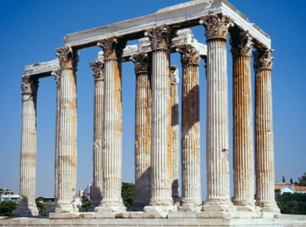
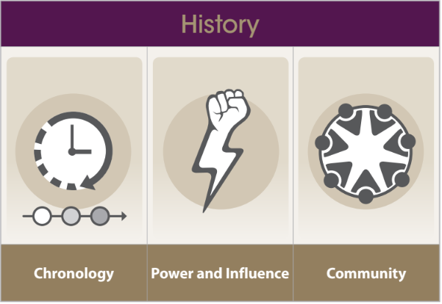
History learning organiser Year 5
Would you rather be a Spartan or an Athenian?

