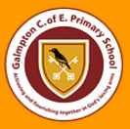
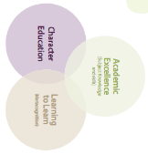
Galmpton C of E Primary Long Term Planner whole school 2024/25

Autumn 1 |  |  | Autumn 2 |  |  | Spring 1 |  | Spring 2 |  |  | Summer 1 |  | Summer 2
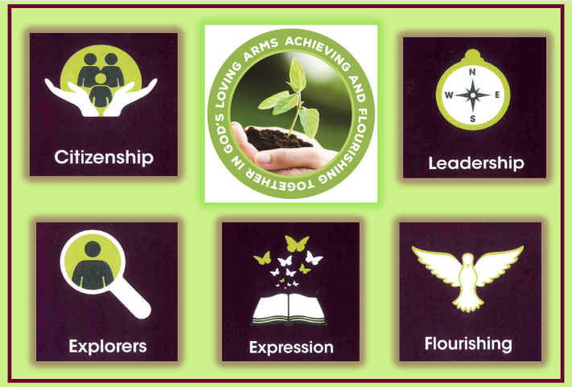  Citizenship |  |  | Exploration   |  |  |   Leadership |  |   Expression |  |  | 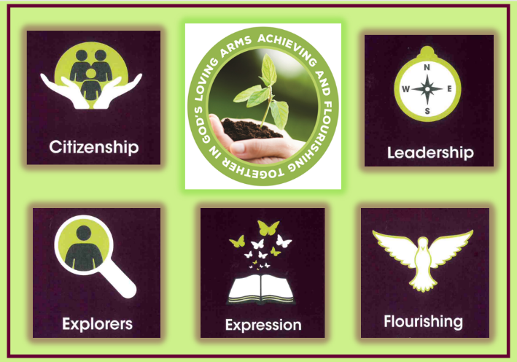  Flourishing |  | Citizenship  
Subject Learning Enquiries
Metacognitive strand  Independence |  |  | Metacognitive strand  Creativity |  |  | Metacognitive strand  Collaboration |  | Metacognitive strand  Independence |  |  | Metacognitive strand  Creativity |  | Metacognitive strand  Collaboration
RSHE  2 weeks | RWE  2 | Geography  3 weeks | Science  3 weeks | Narrative  Writing  2 weeks | Art  2 weeks | History  2 weeks 3 days | Science  3 weeks | Writing  2 weeks | DT  2 weeks | Art  2 week | Geography  2 weeks | Science  2 weeks  3 days | History  3 weeks | DT  Cooking  1 week | RSE 2 days | Music/  Drama  2 weeks
How can the Windrush story shape our response to racism and immigration now? | What are my worldviews? | Natural disaster or man-made – why was Libya so vulnerable to flooding? | What effect do forces have on us, the Earth and our Solar System? | How can we spread wonder and joy this Christmas to others? | Sewing – Christmas cards | Who was the Most Effective Aztec Leader? | Why do states Matter? | Whole school writing  Enquiry. | How can I use my knowledge of forces to make a toy? | Water colours  How can I create a piece of art in the style of Georgia O’Keeffe? | What does it mean to be forced to flee? | What is the strangest life cycle in nature? | Would you rather be a Spartan or an Athenian? | Whole school cooking project | How does my body change during puberty? | Whole school music Enquiry.
Writing Genre
Poetry | Reflective writing | News article | Non-Chron Report | Narrative | Critical review and reflections | Balanced Argument | Explanation | Narrative | Reflections | Biography | Non-Chron report | Persuasive text | Diary | Reflections | - | Play/script
Teaching of Other Subjects
Metacognition (learning to learn day takes places on the first day of every half term)
Religion and Worldviews – a core subject also taught weekly Music- weekly lessons using the Charanga programme MFL-weekly lessons using the PLN Spanish Programme
PE/Games including swimming in KS2 taught weekly

