End of Enquiry Learning:
Knowledge
- I know what gravity is and the impact it has on falling objects.
- I know the effects of air resistance, water resistance and friction.
- I know how forces effect the movement of the earth and smaller planets relative to the sun in the solar system.
- I can name the planets in the solar system and identify them in order of orbit around the sun.
- I know how to describe the shape and movement of the sun, earth, and moon.
- I know how to explain day and night and the apparent movement of the sun across the sky.
- I know that the Earth tilts on its axis - link to summer and winter in northern hemisphere and southern hemisphere.
Skills
- I can plan an investigation that demonstrates how I have considered how the variables need to be controlled for the test to be fair.
- I can say 4 reasons why my test is fair.
- I can use data that I have analysed to find trends and outliers.
- I can explain how I have used prior knowledge to help me form my hypothesis.
- I can demonstrate how the constant evaluation of my investigation has helped ensure fair and accurate results.
- Where there are anomalies, I can evaluate the test and results and say why these might be.
- I can compare my results against other similar results in order to help evaluate accuracy.
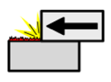
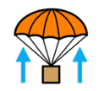
Friction
Air resistance
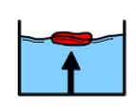
Water resistance
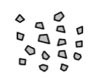
Particles

Surface area
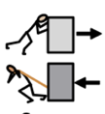
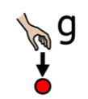
Gravity
Force
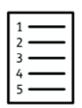
Data

Hypothesis
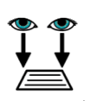
Observation

Fair test
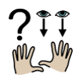
Research
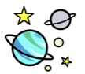
Space

Orbit
Solar system

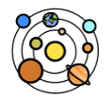
Spherical

Phases

Reliability/ valitidity
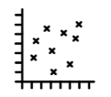
Scatter graph
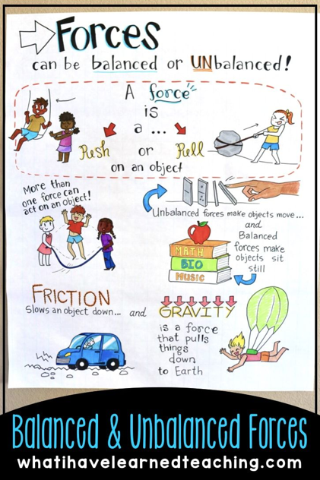

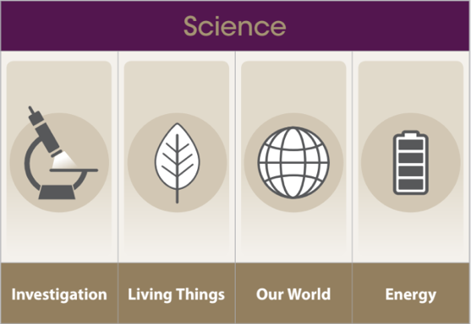
What effects do forces have on us, the Earth and our Solar System?

Year 5 Science Learning Organiser

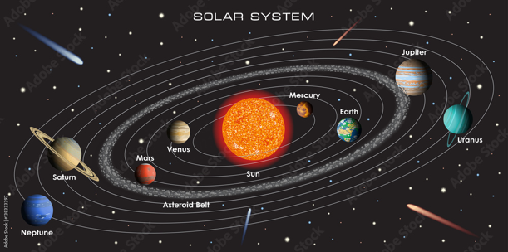

Friction
Air resistance
Water resistance
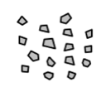
Particles
Surface area
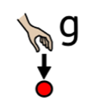
Gravity
Force
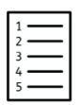
Data
Hypothesis
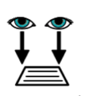
Observation
Fair test
Research
Space
Orbit
Solar system
Spherical
Phases
Reliability
Scatter graph
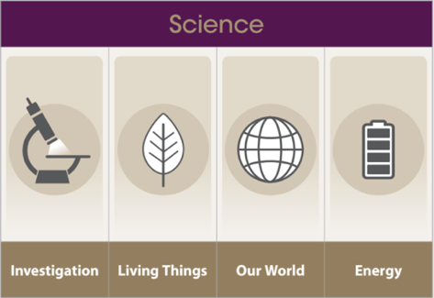
Year 5 Science Learning Organiser

What effects do forces have on us, the Earth and our Solar System?

End of Enquiry Learning:
Knowledge
- I know what gravity is and the impact it has on falling objects.
- I know the effects of air resistance, water resistance and friction.
- I know how forces effect the movement of the earth and smaller planets relative to the sun in the solar system.
- I can name the planets in the solar system and identify them in order of orbit around the sun.
- I know how to describe the shape and movement of the sun, earth, and moon.
- I know how to explain day and night and the apparent movement of the sun across the sky.
- I know that the Earth tilts on its axis - link to summer and winter in northern hemisphere and southern hemisphere.
Skills
- I can say 2 reasons why my test is fair.
- I can plan an investigation that demonstrates how I have considered the need for the test to fair and unbiased.
- I can collect a range of measurements and data to make comparison and check for anomalies.
- I can explain which measurements I am taking and the reliability of these.
- I can design a table or chart that enables me to display my data collected in the most informative way.
- I can explain how the conclusion of my investigation relates to my hypothesis.
- I can explain how I have used prior knowledge to help me form my hypothesis.
- Where there are anomalies, I can evaluate the test and results and say why these might be.
- I can evaluate the results of my Investigation and explain why they are not biased.
- I can use my results to prove or disprove the hypothesis using a balanced argument.

